How to measure time – pendulum clocks

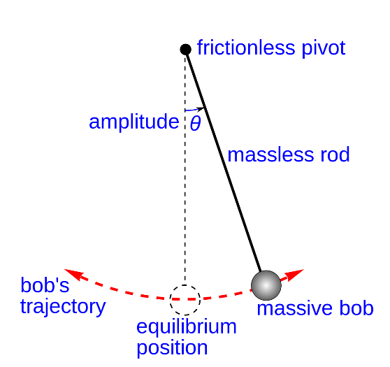
Younger students
1. Qualitatively: No watch, no cell phone. Open experiment: Identify relevant parameters – include/exclude
2. Quantitatively: Using a cell phone to study the same relationships as in 1, e.g. period versus mass, period vs length
3. Data analysis. Scatter plot, Power regression.

Math part: Finding the relationship between T and L, studying power functions
Physics part: Doing the experiments, no theory.

More advanced students
1. Head on: measuring the distance from the motion sensor to the pendulum as a function of time.
Study influence, if any, of mass, length, amplitude and damping on the period T.
2. Data analysis: Study the graph, fit a harmonic function.

Math part: study trig functions including amplitude, frequency, period.
Physics part: Doing the experiments, no theory (maybe study the forces to arrive at the formula)
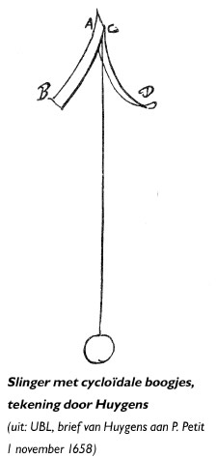

The physics behind the pendulum is: $T=2 . π. \sqrt{\frac{l}{g}}$ with l the length of the pendulum and g the gravitational acceleration 9,81 m/s².

For large deviations there has to be a correction as mentioned by Christian Huygens (1658). See picture beside.

Equipment that can be used for experiments:
- Ranger for motion
- Stopwatch for time measurement
- App for video measurements

Extra reading materials: John Harrison clock maker from 17 th century and inventor of the marine chronometer.

